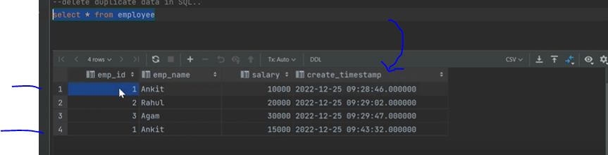

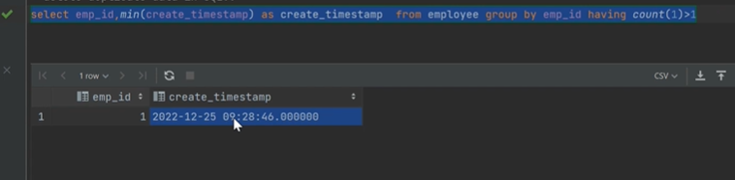

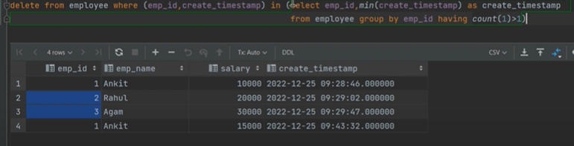

For other columns:

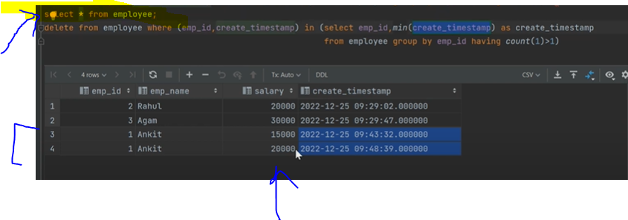



**Pure duplicates**. i.e value is same in each column, so here ,be careful while deleting ,otherwise it will delete all of them.

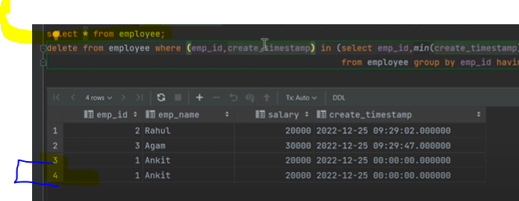

Deleted all

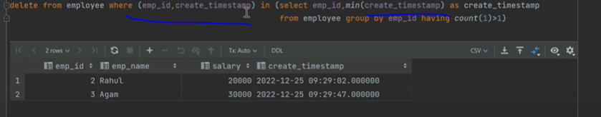

So, what is the solution:

1. Take Backe-up

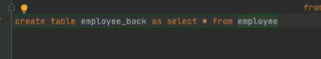

See this works :

1. Now

Delete the original table ,here Employee

After that from back-up ,find distinct and insert into original table.

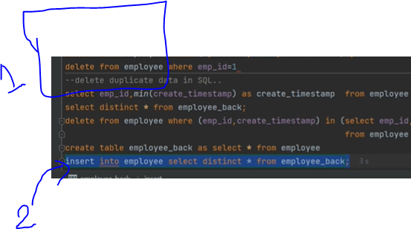

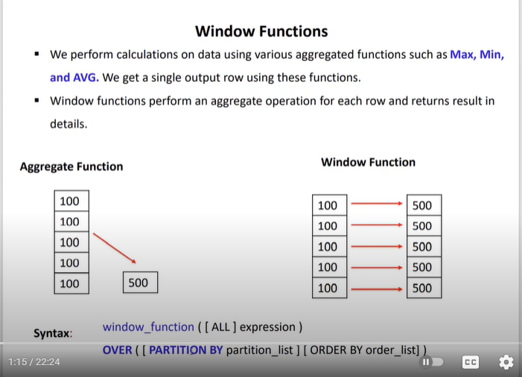

We can mix , aggregation and non-aagregation, so what is the solution



